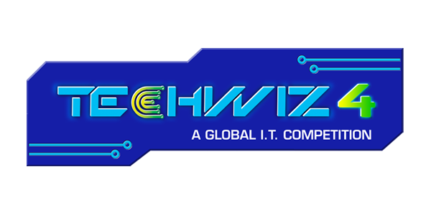

**Smart Farm IOT Solution**

# **Abstract:**

Agriculture is facing a number of complicated challenges that are impeding productivity, sustainability, and economic viability. Among the pressing challenges are the effects of climate change, water scarcity, soil degradation, pests and illnesses, market access hurdles, workforce shortages, and rural-urban migration. This abstract presents a comprehensive way to addressing these issues. Implementing climate-resilient farming practices, optimizing water management strategies, promoting soil conservation and restoration methods, adopting integrated pest management techniques, improving market access and infrastructure, providing farmers with education and skill development, leveraging technology adoption, initiating rural development initiatives, reforming land tenure systems, stabilizing market prices, and prioritizing the environment are among the suggested solutions. The successful deployment of these ideas necessitates government collaboration.

# **Problem statement:**

Agriculture faces a range of issues, which vary depending on place and context, but some common ones include:

**Climate change** can interrupt crop cycles and reduce yields by causing erratic weather patterns, severe temperatures, droughts, and floods.

**Water Scarcity**: Water scarcity affects irrigation and crop growth in many locations.

**Soil Degradation**: Excessive land usage, erosion, and poor farming techniques can all contribute to soil depletion and diminished fertility.

**Insects, diseases**, and weeds can harm crops and lower yields, resulting in considerable economic losses.

# **Proposed Solution:**

Among the proposed answers to agricultural challenges are:

Climate-Resilient Farming Practices: Promoting the use of climate-smart farming techniques that are more adaptable to shifting weather patterns and harsh conditions.

Water management entails using efficient irrigation methods, practicing water conservation, and investing in water storage and delivery infrastructure.

Soil conservation and restoration entails promoting sustainable land management strategies such as cover cropping, crop rotation, and agroforestry in order to minimize soil deterioration and increase fertility.

Integrated Pest Management (IPM) is the use of a combination of biological, chemical, and cultural approaches to manage pests and diseases while having the least possible impact on the environment.

# **Design/Architecture**:

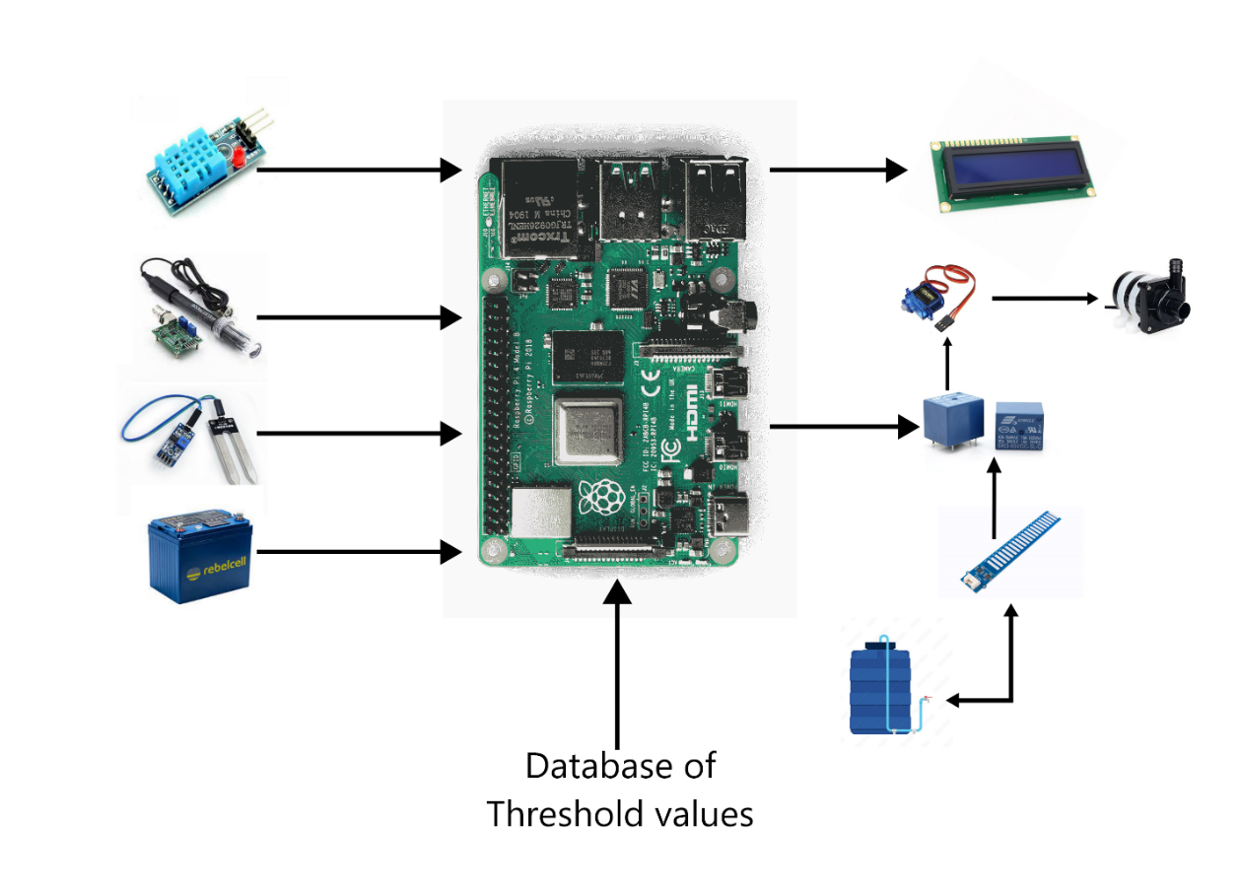

# **Components/Model:**

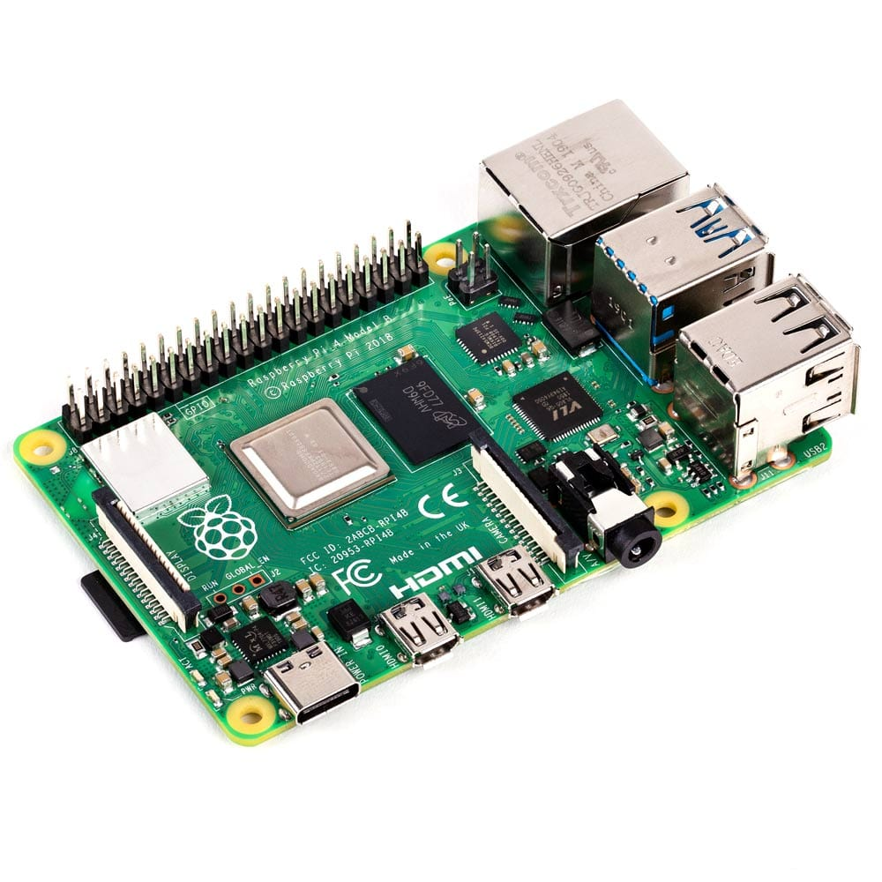

**Raspberry Pi:**

The Raspberry Pi is a line of compact, single-board computers created by the Raspberry Pi Foundation. These computers are intended to be inexpensive, portable, and versatile, making them perfect for a variety of educational, hobbyist, and do-it-yourself tasks. The Raspberry Pi boards are well-known for their capacity to run a variety of operating systems and software, which has made them famous in sectors such as programming, electronics, robotics, and others.

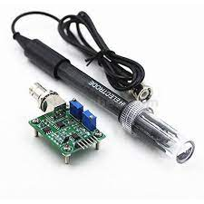

**PH Sensor:**

A pH sensor is a device that measures the pH of a solution to determine its acidity or alkalinity. The concentration of hydrogen ions (H+) in a solution is measured using a pH scale ranging from 0 to 14, with 7 being considered neutral.

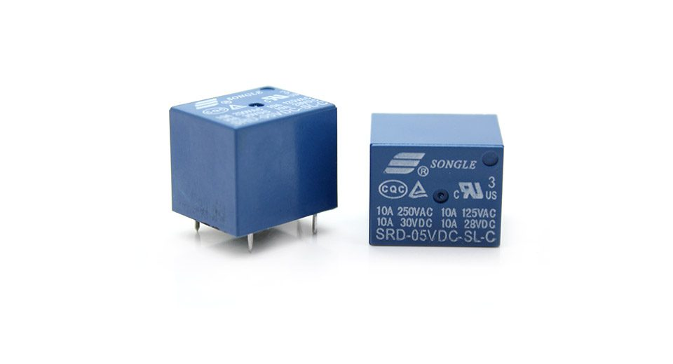

**Relay 10A:**

A relay is an electrical device that uses a tiny control signal to switch a bigger electrical load. It is frequently used to operate circuits with low-power signals, such as a switch controlling a high-power light or motor.

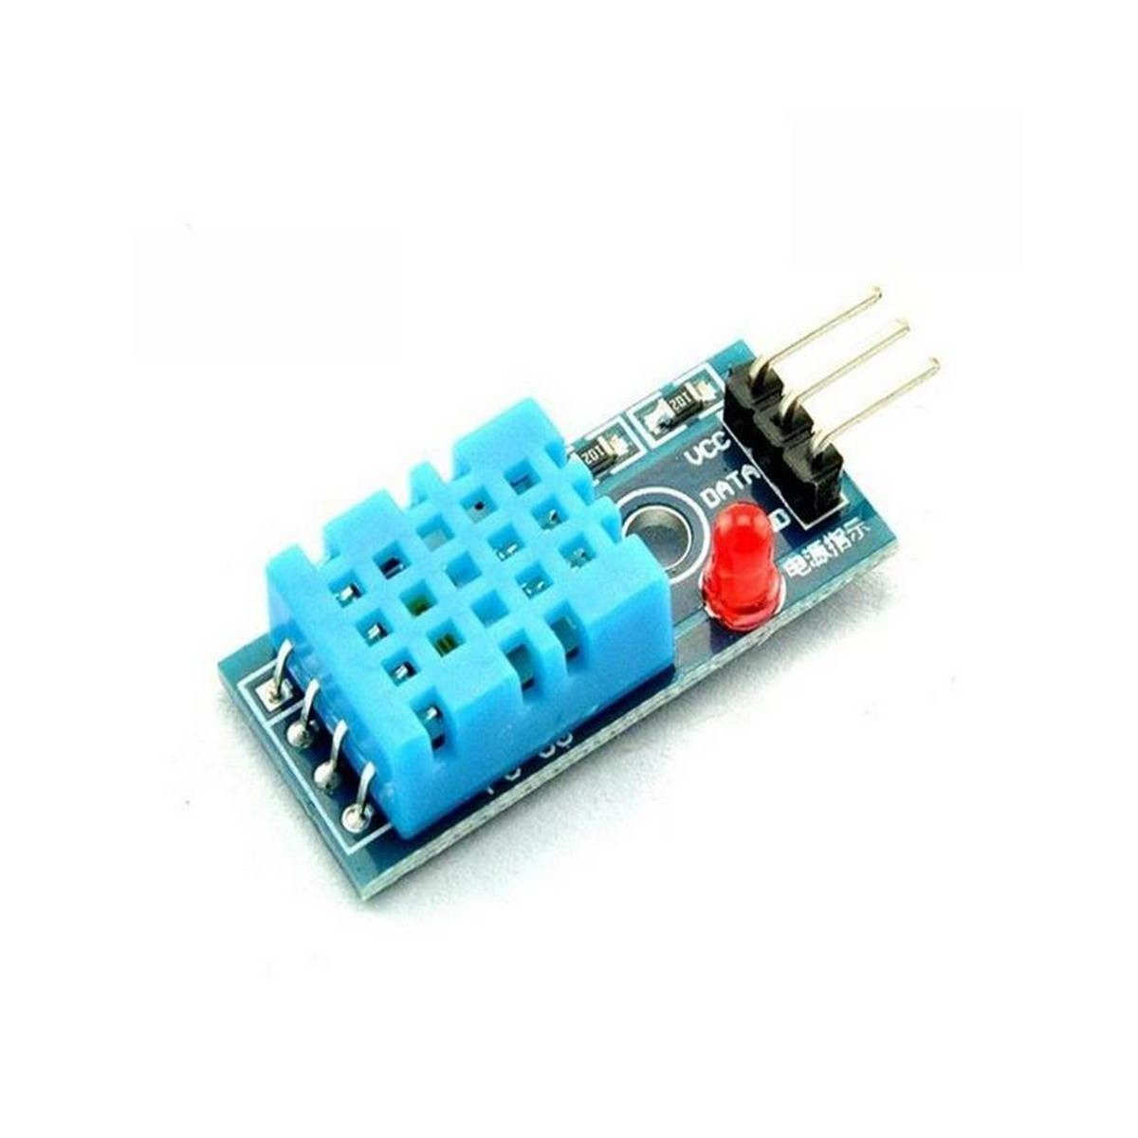

**DHT11 Sensor:**

The DHT11 sensor is a basic digital temperature and humidity sensor commonly used in various applications, including home automation, weather stations, and environmental monitoring. It's designed to provide accurate measurements of temperature and humidity levels in its immediate surroundings.

high-power light or motor.

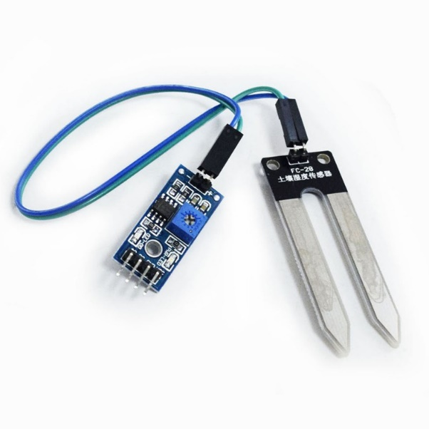

**Soil Moisture Sensor:**

A soil moisture sensor is a device that measures soil moisture content. These sensors are often used to optimize irrigation and watering systems in agriculture, gardening, and environmental monitoring. They can also be integrated into projects that use Raspberry Pi platforms for automated plant care, data logging, and analysis.

**LCD (Liquid Crystal Display):**

An LCD (Liquid Crystal Display) screen can be a handy addition to your Raspberry Pi project because it allows you to visually display information, graphics, and interact with your device.

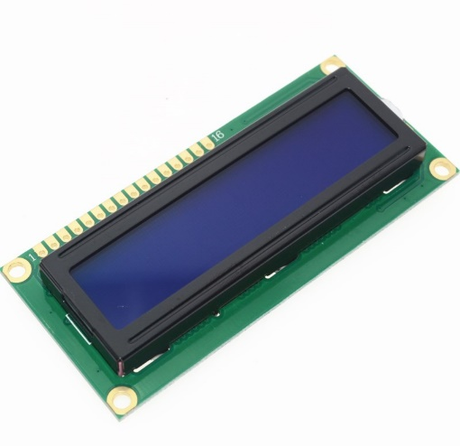

**Servo Motor:**

A servo motor is a type of rotary actuator that controls angular position, velocity, and acceleration precisely. Robotics, automation, remote-controlled vehicles, 3D printers, and other applications make extensive use of servo motors. They are especially effective when precise and repeatable movement control is required.

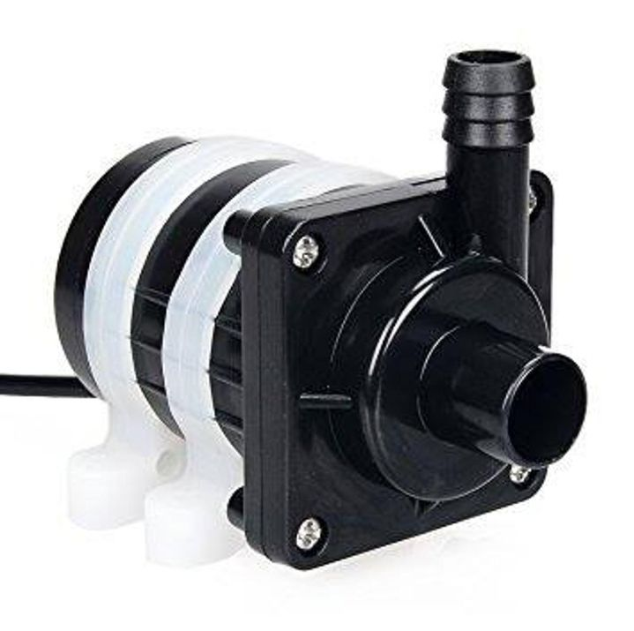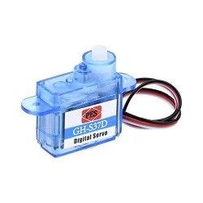

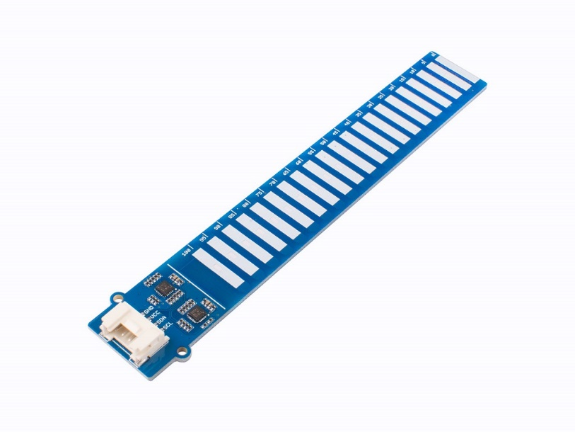

**DC Pump:**

A servo motor is a type of rotary actuator that controls angular position, velocity, and acceleration precisely. Robotics, automation, remote-controlled vehicles, 3D printers, and other applications make extensive use of servo motors. They are especially effective when precise and repeatable movement control is required.

**Water Level Sensor:**

The depth or height of a liquid surface, such as water, in a container or tank can be determined with a water level sensor. These sensors are utilized in a variety of applications, such as irrigation systems, industrial tanks, aquariums, and water level monitoring. A Raspberry Pi can be connected to water level sensors to build automated systems that react to shifting water levels.

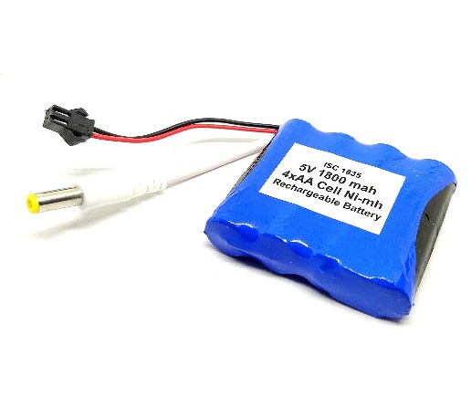

**Battery:**

Batteries are undoubtedly tools that use chemical processes to store and deliver electrical energy. They are frequently used to power a range of devices, from little gadgets like remote controls and cellphones to bigger ones like cars and backup power sources. Batteries exist in a variety of shapes, sizes, and chemistries, each having unique properties and uses.

**Model Structure:**

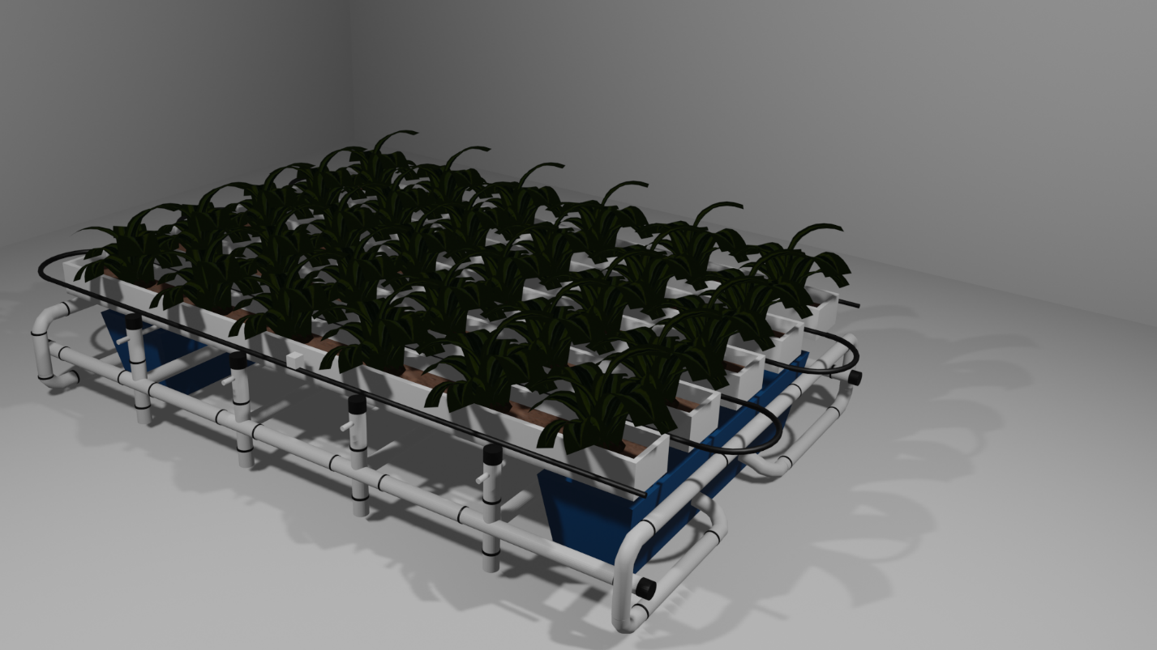

**Circuits:**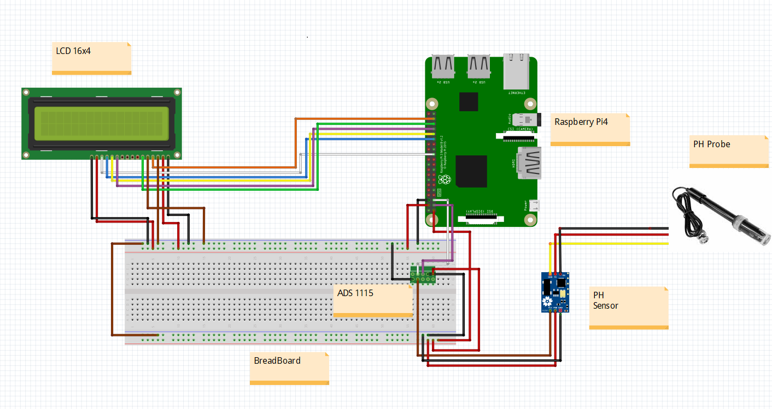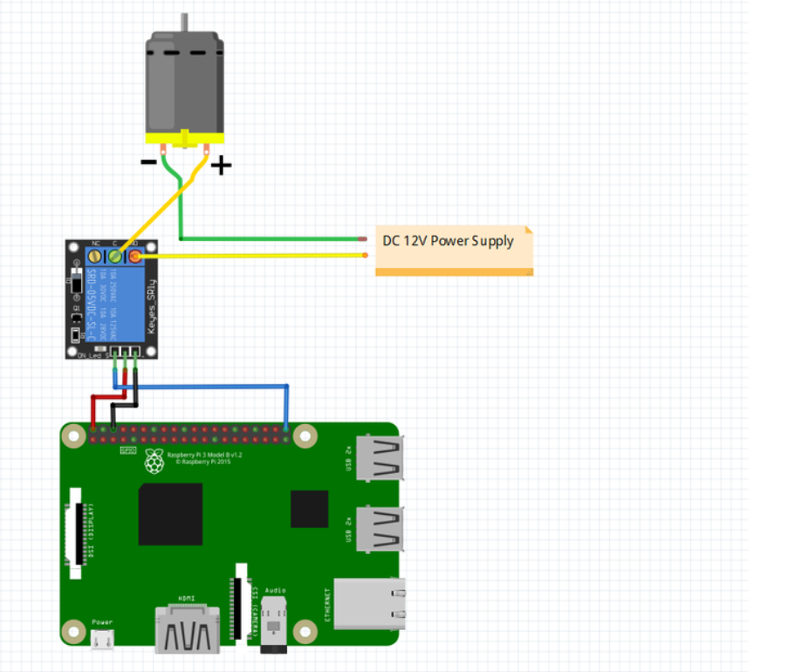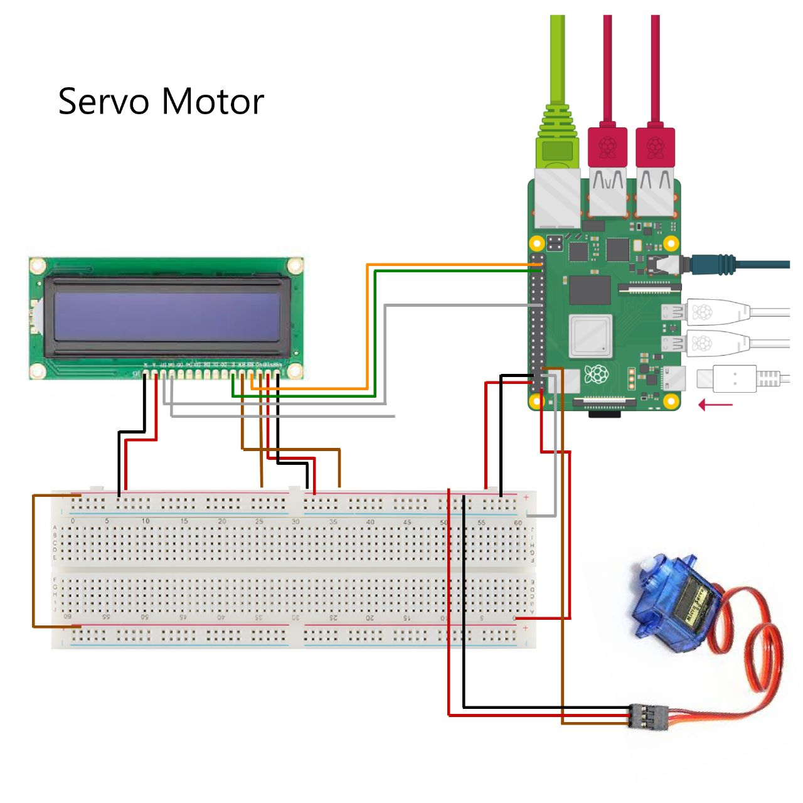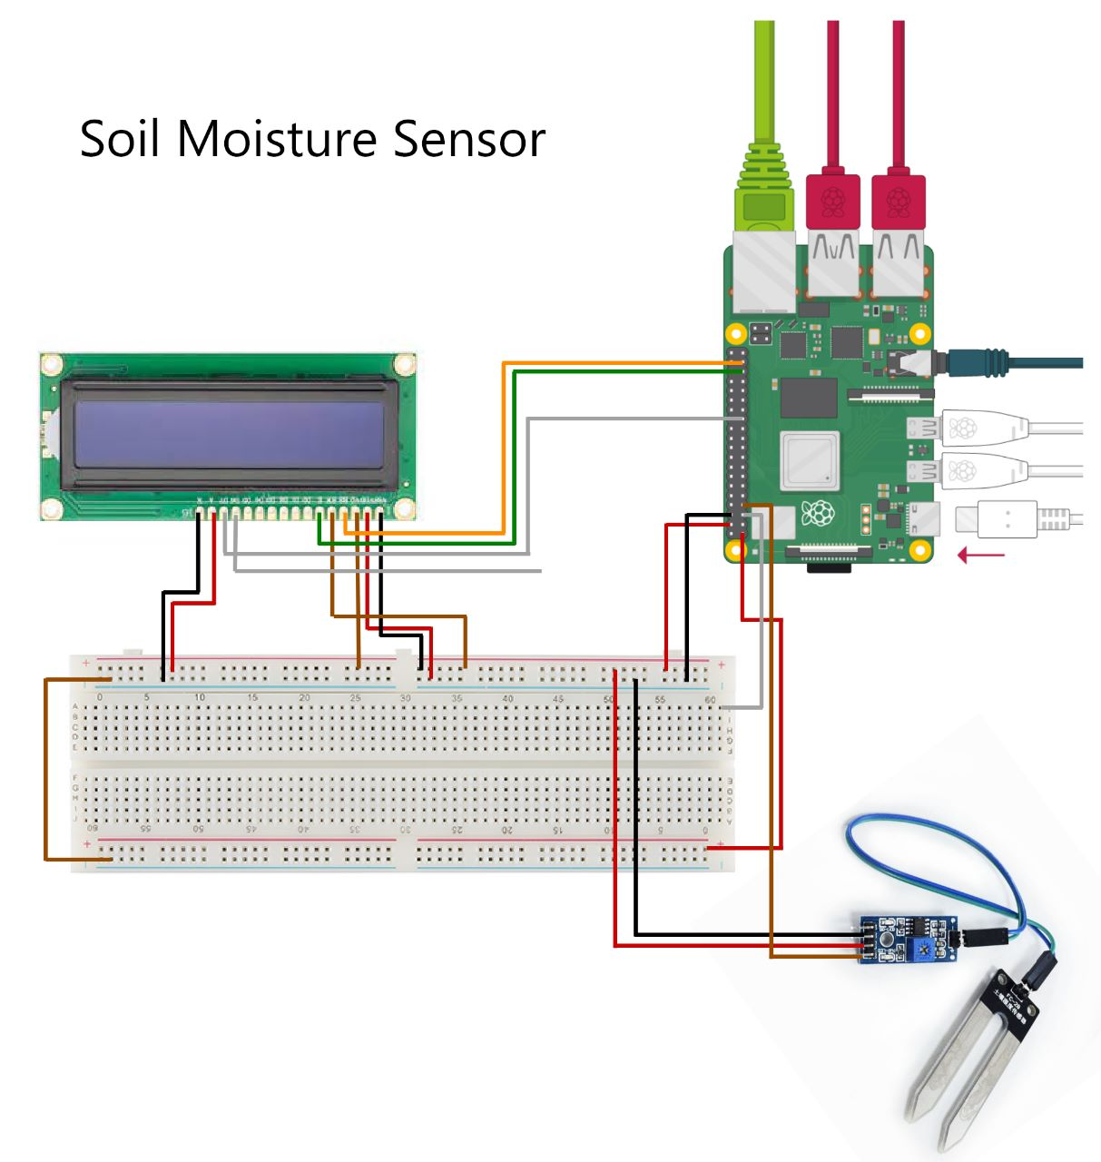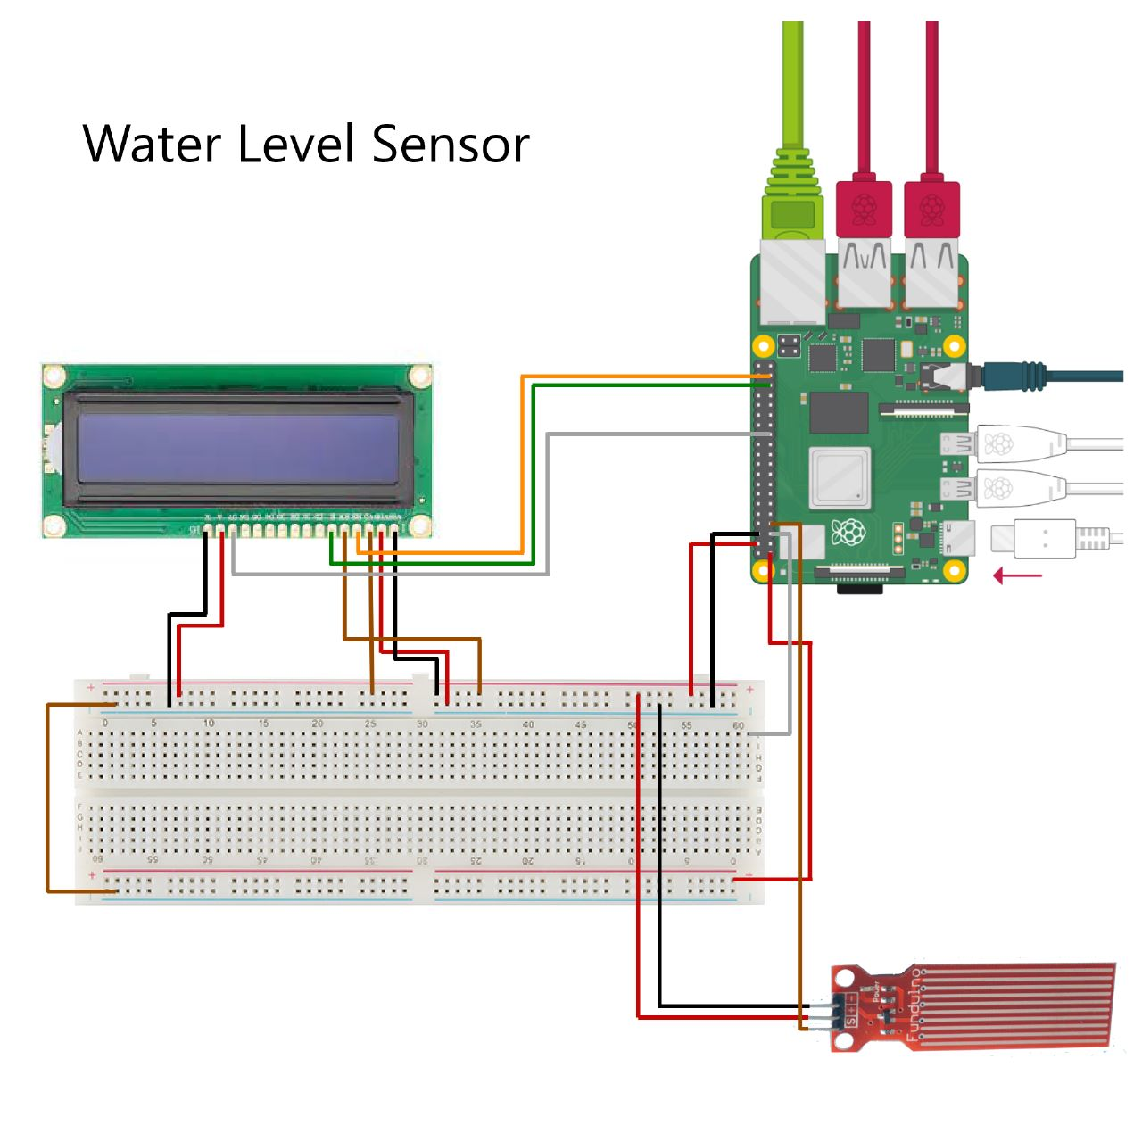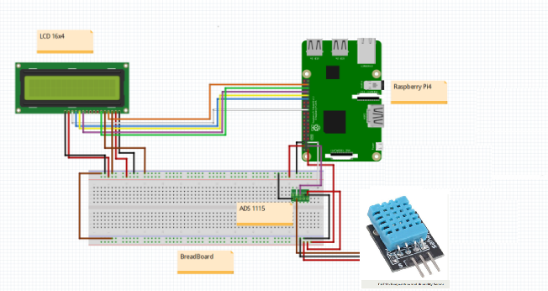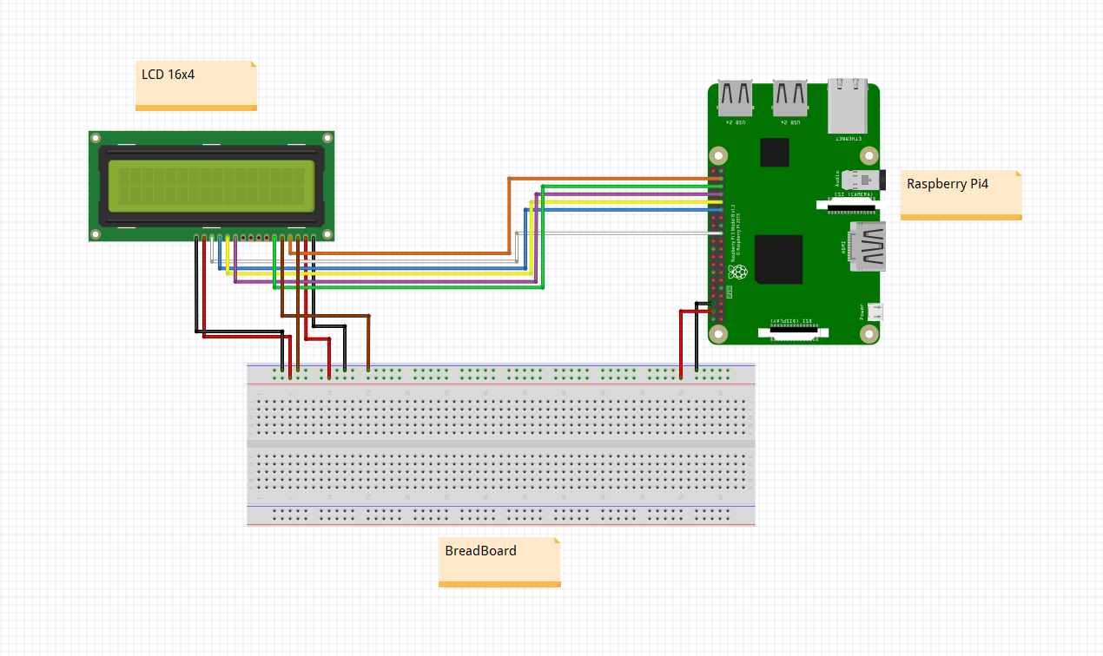

# **Issues/Solution:**

Here are some agricultural concerns and possible solutions:

Impacts of Climate Change

To offset the effects of shifting weather patterns, implement climate-resilient farming practices such as drought-tolerant crops, enhanced irrigation, and agroforestry.

Water scarcity is a problem.

Solution: To optimize water use, employ efficient irrigation technologies such as drip irrigation and rainwater harvesting, and invest in water storage and distribution infrastructure.

Problem: Soil Degradation

Solution: To increase soil health and minimize erosion, promote sustainable land management strategies such as cover cropping, crop rotation, and reduced tillage.

Pests and diseases are a problem.

To reduce insect damage, implement integrated pest management tactics that incorporate biological controls, natural predators, and targeted chemical use.

# **Conclusion:**

In conclusion, the adoption of smart technologies in agriculture has resulted in game-changing answers to the industry's many problems. With the use of data, automation, and connection, smart agriculture has completely changed how farmers run their businesses, make the best use of resources, and increase productivity.

Smart agriculture has made it possible for farmers to make well-informed decisions that increase yields and have a smaller negative impact on the environment, from improving water management with real-time soil moisture data and weather forecasts to identifying crop diseases early using enhanced imaging and computer vision. In addition to enhancing crop health, precision approaches like GPS-guided fertilizer application have also reduced resource waste and pollution.

Additionally, the use of agricultural robotics and automation has reduced the demand for labor-intensive manual jobs and eased labor shortages. By using fewer chemicals and boosting overall productivity, these solutions not only increase operational effectiveness but also support more environmentally friendly practices.

With the use of sensor networks and data analysis, smart agriculture's predictive capabilities have allowed farmers to foresee pest outbreaks and take preventative action. This early action benefits ecosystem health because it not only safeguards crop but also lessens the need for overuse of pesticides.

A road to achieving food security, sustainability, and economic viability is provided by the innovation of smart agriculture in a world that is changing quickly due to rising population demands and environmental concerns. The agriculture industry is well-positioned to prosper while conserving valuable resources and protecting the environment for future generations by embracing technology and data-driven solutions. The transition to smart agriculture is a crucial step in the direction of a more resilient, effective, and sustainable agricultural future.